2017 - 2018 10-15-17

GSK CATHOLIC FAITH-BASED PROGRAMS & RELIGIOUS AWARDS

RELIGIOUS AWARDS CEREMONY & RECEPTION for GIRLS & ADULTS

Ceremony will be held at the Cathedral of the Assumption at 2 pm on Sunday, March 11, 2018
with the Reception immediately following in the Undercroft.
*One adult from each troop participating is REQUIRED to attend the Ceremony planning meeting
on January 29, 2018 at Our Lady of Lourdes.

t ADULT CATHOLIC RELIGIOUS AWARDS

- Request information & applications from Phyllis Gilman or Ann Russo (emails below)
- Completed applications should be turned into GSK Catholic Religious Awards Committee Chairs, Phyllis & Ann.
- Award pin should be purchased by the nominator, to be blessed & presented to the nominee at the Ceremony.

t GIRLS’ PROGRAM MATERIALS to earn their Religious Awards
- MY PROMISE, MY FAITH (MPMF) is the GSUSA Girl Scout Program for all GS levels, found in each of the GSUSA Girl Guides. http://www.girlscouts.org/en/about-girl-scouts/girl-scouts-and-faith.html
- Leaders may purchase pins from the GSK shop to give their girls at completion of program or at end-of-year.
- Girls who have received their MPMF pins, may be recognized as a group at the Religious Awards Ceremony.

- NATIONAL FEDERATION OF CATHOLIC YOUTH MINISTRY (NFCYM)

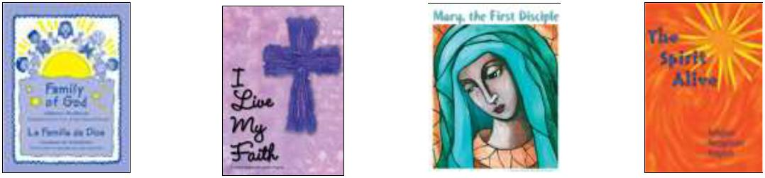

Grades K & 1 Grades 2 & 3 Grades 4, 5 & 6 Grades 7 & 8 Grades 9-12

- Ceremony planning meeting is MANDATORY for adults with any girls participating at 6:30 pm on January 29, 2018 at Our Lady of Lourdes Parish Center basement, 508 Breckenridge Ln, 40207.
- It is recommended to check with your Parish Youth Ministry Coordinator or Director of Religious Education to let them know you are working on the program, as well as ask if they have a Youth budget that may help subsidize the costs of the program materials & award medals.
- These programs are to be completed by the girls to participate in the Ceremony in March & are available for Leader to order from NFCYM.
- New NFCYM requirement - Leaders/advisors must now order ONE workbook per girl to be able to order their Religious
Award medal. Leaders order Program materials directly from the online store http://store.nfcym.org/shop/pc/GS-CF-Rel-Rec-Program-Books-c8.htm?pageStyle=h&ProdSort=19&page=6&idCategory=8&viewAll=yes
- IMPORTANT NOTE: ALL GIRL-EARNED religious Medals & Patches MUST be ordered through the Archdiocese of Louisville, Vivian Cornell, VCornell@archlou.org, 502-636-0296 X 1207
- Leaders, when ordering Award materials from Vivian, please include your NFCYM workbook receipt along with a cover note including your credit or debit card number & mailing address. The Awards will be sent directly to you from NFCYM.
- Even if you haven’t completed the program workbooks yet, please make sure to place your order by February 15th to receive the awards in time for the Ceremony!

t ADDITIONAL CATHOLIC RESOURCES, PROGRAMS & PATCHES CAN BE FOUND ON THESE WEBSITES
- Programs for Religious Activities with Youth https://www.praypub.org/gsusa Resources to earn religious awards for Catholic GS. Has link to page showing how religious awards and GS My Promise, My Faith (MPMF) programs compare & complement each other.
- The National Catholic Committee on Girl Scouts and Camp Fire (NCCGSCF) is a committee of NFCYM http://www.nfcym.org/about-nccgscf/ There are 3 drop-down menus: under ‘About’ you will find any new information. Under ‘Religious Recognition Program…’ are all Award programs & additional badges for girls & adults.
DEVELOPMENT OF PROGRAM & COMMITTEES for 2017-18 Troop year Ceremony & Reception
To be put on contact list to receive meeting information, or if you have any additional questions, please contact

Phyllis Gilman, PAGilman80@gmail.com or Ann Russo, AnnKRusso@att.net

Co-chairs of the Catholic Initiatives Subcommittee, Girl Scouts of Kentuckiana Council Faith-Based Experience Committee
& Archdiocese of Louisville Catholic Committee on Scouting http://archlouccs.org/a/
Be sure to check out the GSK Catholic Girl Scouts on Facebook for updates!
Thank you very much for your interest, enthusiasm & dedication to your faith & your Catholic GS!

